COMPUTER VISION- ITA0506 HARSHITHA G S
192421221
CO3 AT1
EXPERIMENTS

1. Feature Descriptor Comparison — SIFT vs Harris
AIM
To compare Harris Corner Detection and SIFT feature extraction on the same image and analyze the detected features.
PROCEDURE
- Read the input image.
- Convert the image into grayscale.
- Apply Harris Corner Detection.
- Detect SIFT keypoints and descriptors.
- Draw the detected features on the image.
- Display and compare the outputs.

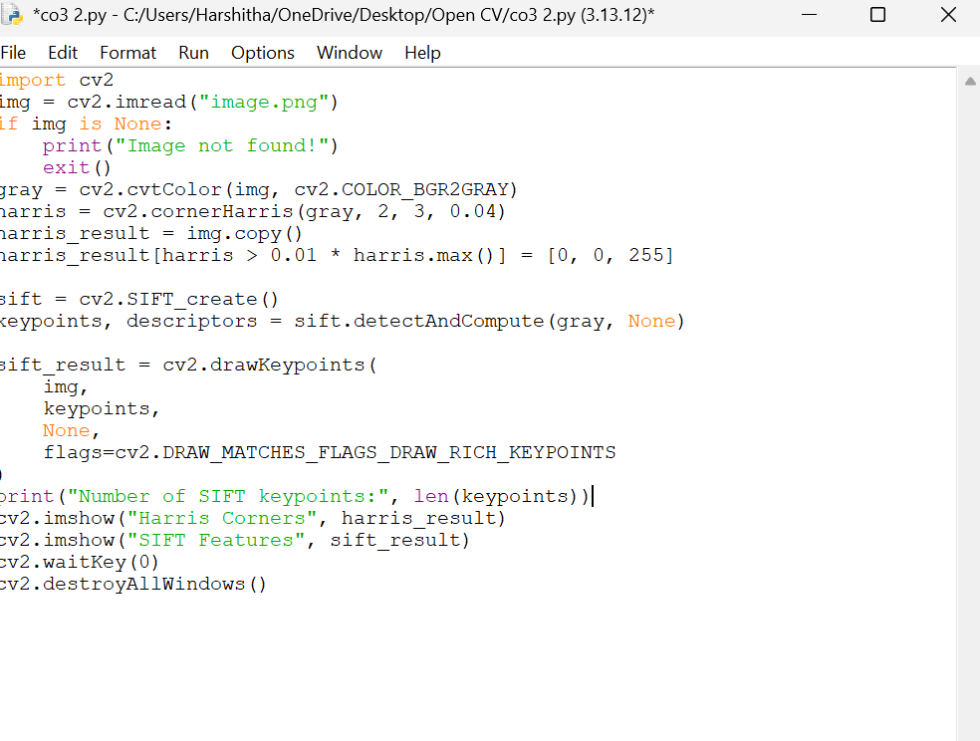
CODE

INPUT
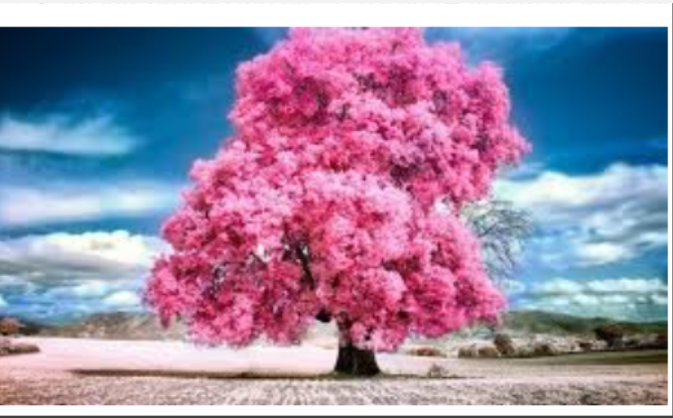

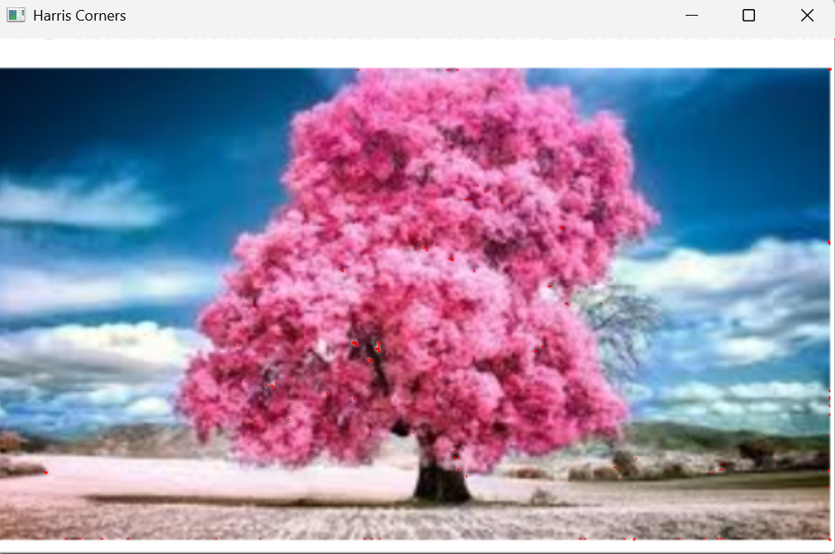
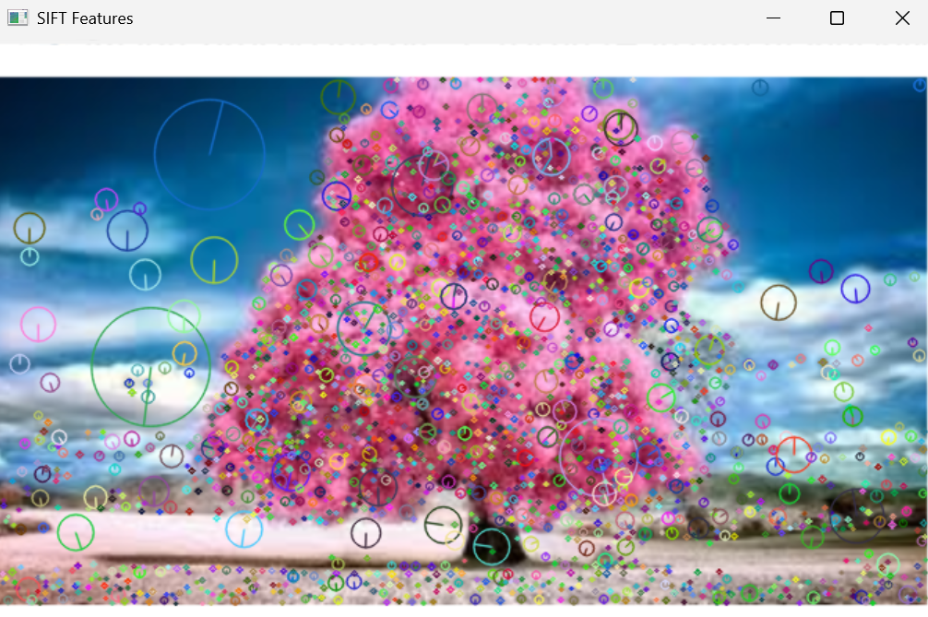
OUTPUT

2. Image Enhancement for Feature Detection
AIM
To study the effect of histogram equalization and contrast adjustment on feature detection performance.
PROCEDURE
- Read the input image.
- Convert it into grayscale.
- Apply histogram equalization.
- Apply contrast adjustment.
- Detect SIFT features in the original and enhanced images.
- Display the results and compare feature detection.

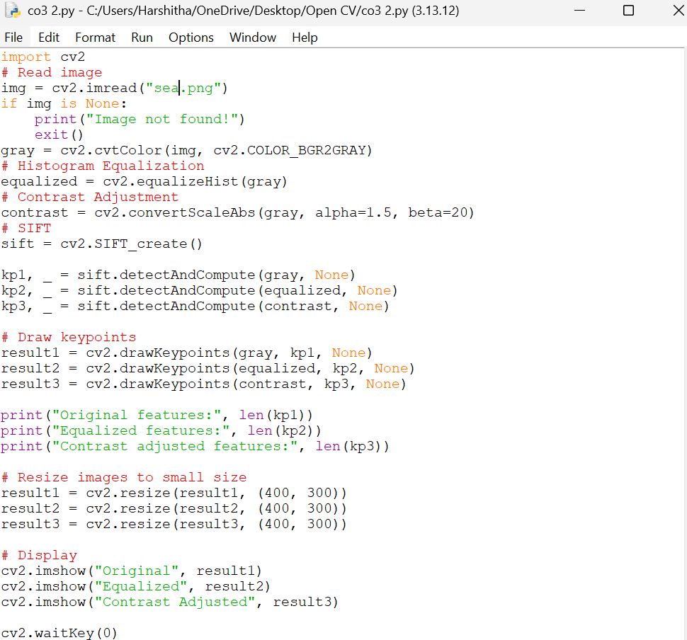
CODE

INPUT


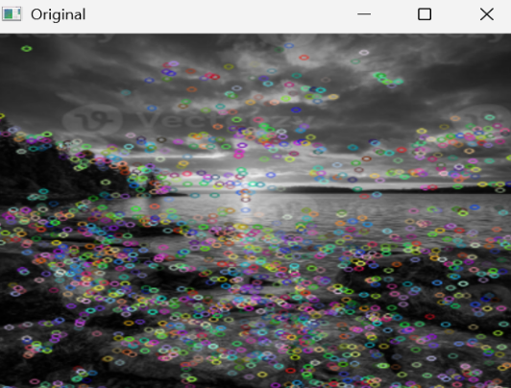
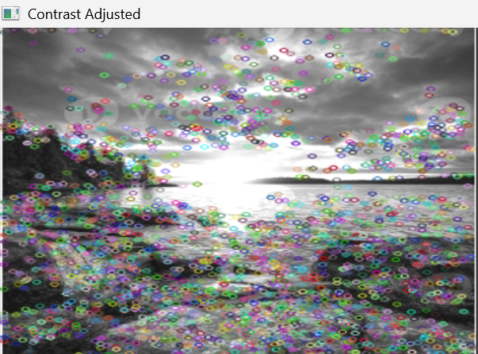
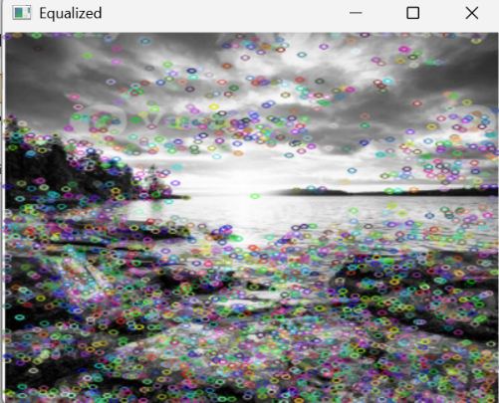
OUTPUT

3. Multi-Scale Feature Detection Analysis
AIM
To study feature detection at different image scales and analyze the effect of image resolution on feature detection.
PROCEDURE
- Read the input image.
- Create different versions of the image by changing its scale.
- Apply SIFT feature detection to each image.
- Count the number of detected keypoints.
- Measure the processing time.
- Display and compare the results.

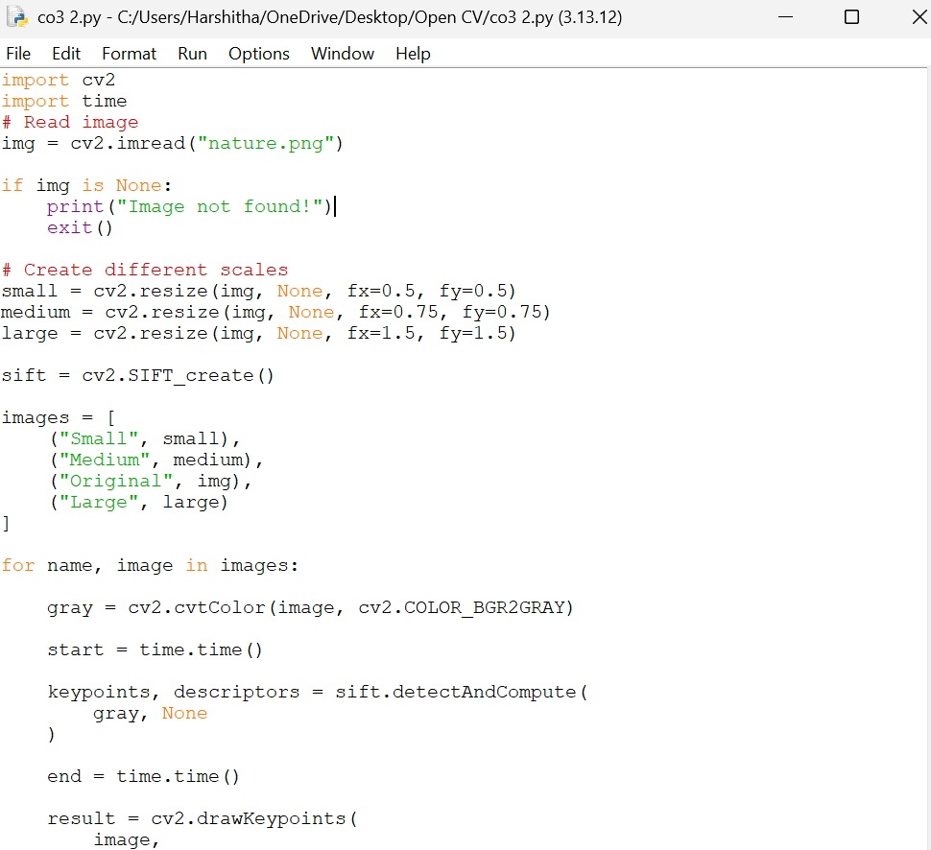
CODE

INPUT
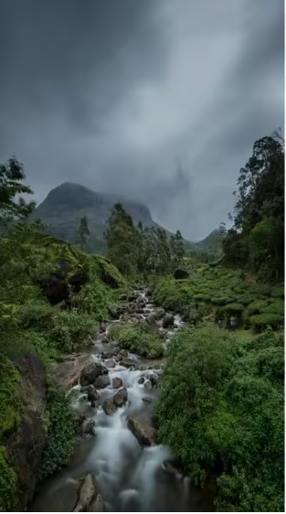

OUTPUT
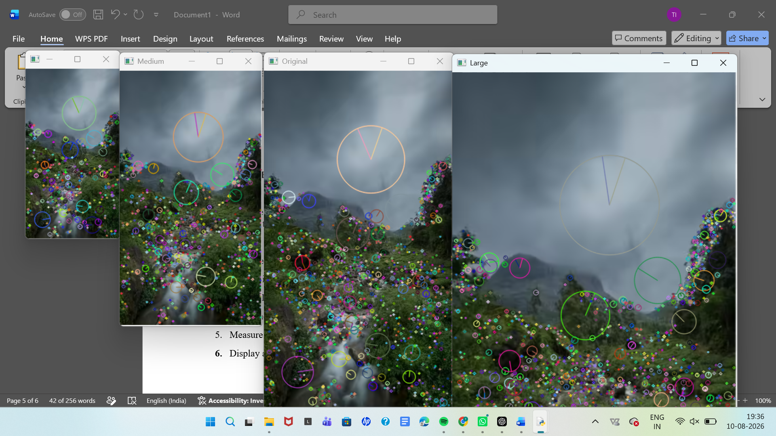

4. Comparative Analysis of Image Filtering Techniques
AIM
To compare Mean, Gaussian, and Median filtering techniques for noise reduction and analyze their ability to preserve image features.
PROCEDURE
- Read the input image.
- Add salt-and-pepper noise to the image.
- Apply Mean filtering.
- Apply Gaussian filtering.
- Apply Median filtering.
- Display the original, noisy, and filtered images.
- Compare the noise reduction results.

CODE
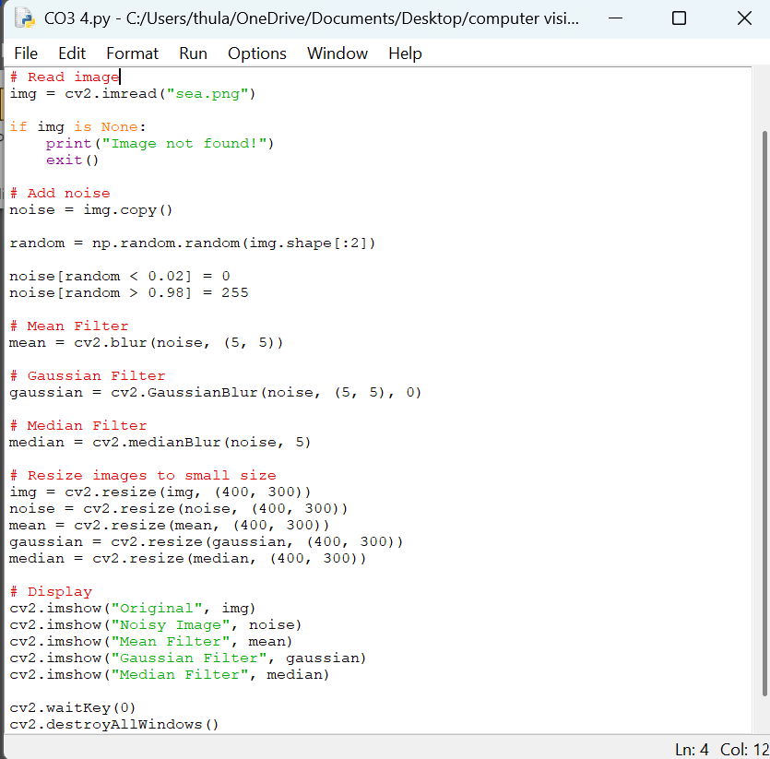

INPUT


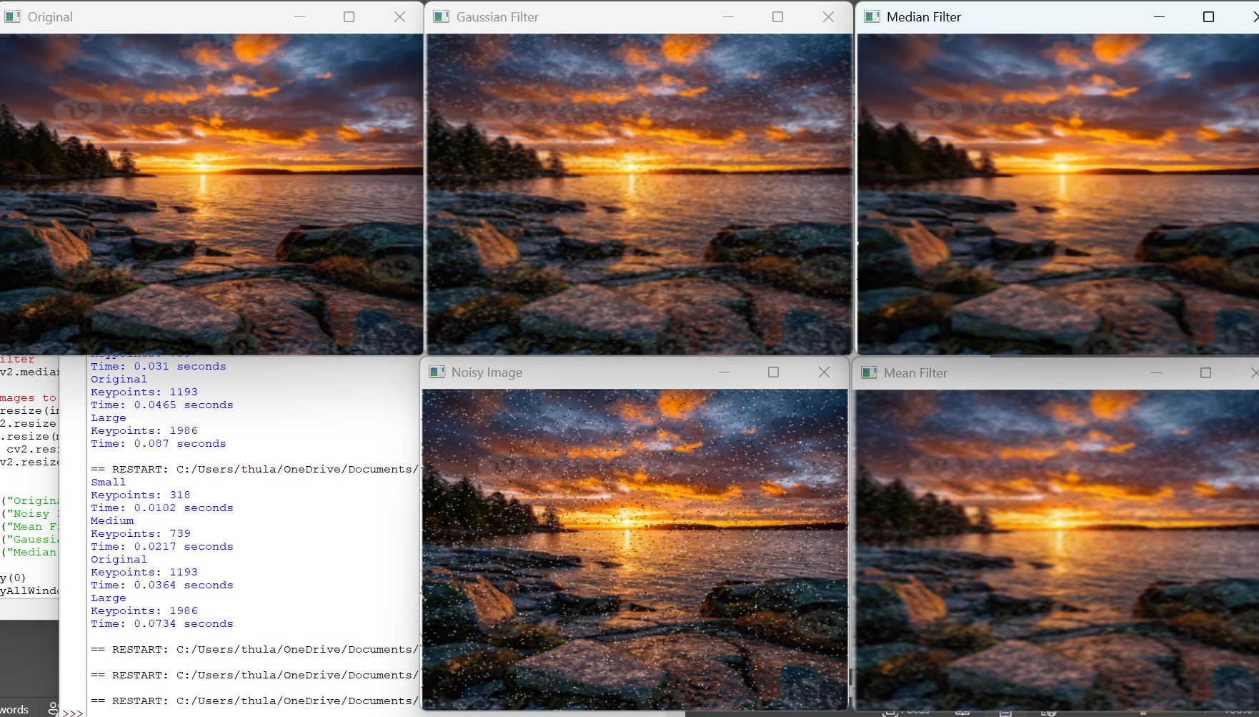
OUTPUT

5. Complete Object Detection Workflow
AIM
To develop a complete object detection workflow using image preprocessing, edge detection, feature extraction, contour detection, and shape detection.
PROCEDURE
- Read the input image.
- Convert the image to grayscale.
- Apply Gaussian blur for preprocessing.
- Apply Canny edge detection.
- Detect contours from the edges.
- Approximate the contours to identify shapes.
- Classify the detected objects as triangle, rectangle, or circle.
- Display the output at every stage.

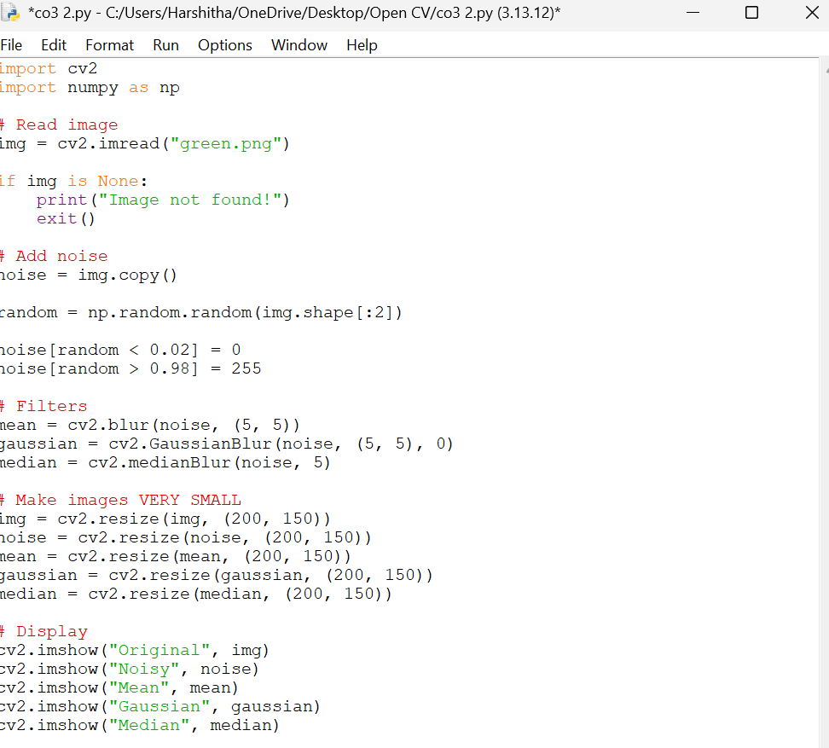
CODE

INPUT


OUTPUT


